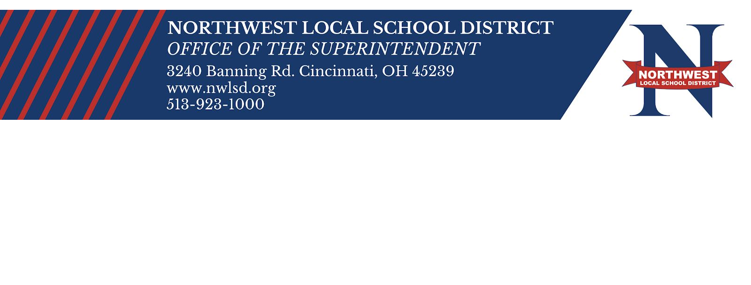
11/19/2020

NWLSD Parents,

With the recent increase of community Covid cases rising, and our recent staff shortages, we have decided to temporarily work remotely starting Monday, November 23 until December 4, 2020. As we look at numbers, we recognize the importance of increasing our window of time to allow symptoms to develop for any staff or students who may have been exposed during the break. Staff and students who are symptom-free will return to school on December 7, 2020. At that time, we will return to our current learning models of in-person and remote.

Please note, information regarding school work and assignments will be communicated by each student’s teacher.

FOOD DISTRIBUTION INFORMATION:
NWLSD will provide an additional meal pick-up opportunity for students on Monday, November 23, from 3:30 PM - 6:30 PM. This pick-up is open to all Preschool through 12th grade students, and includes all in-person and remote learners. Families will be able to pick up 10 breakfast and 10 lunch meals.

Parents will need to submit the Meal Service Request Form. Packaged meals will not be prepared if a Meal Service Request Form is not submitted by Sunday, November 22nd at NOON. All meals will need to be picked up on Monday, November 23, from 3:30 PM - 6:30 PM at: Taylor Elementary, 3173 Springdale Rd., Cincinnati, OH 45251

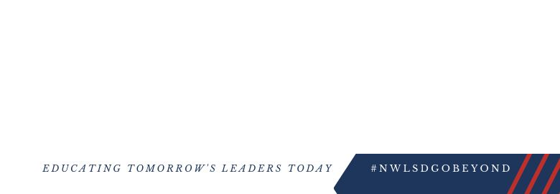
SAFE AND HEALTH CONCERNS
We encourage our families during this time to be safe. As reported, the number of community cases are rising due to small gatherings. Please take measures to protect you and your families’ bubble by practicing social distancing, wearing your masks and making every effort to perform good hand hygiene. Please remember, with or without a mask, you must remain 6 feet apart and keep your personal bubble safe. Dining out or riding in a car with others are some of the leading causes of contracting COVID-19 or causing others to be quarantined. While we understand that we cannot control what takes place outside of school, we ask that you are mindful and take precautions to keep you and your family safe. If you or your child begin to notice symptoms during and/or after Fall Recess, please consult your doctor. We encourage you to get tested. Once you and your child(ren) have been tested, please notify your school by calling the attendance line. We thank you in advance for your commitment a
accept that we

Todd Bowling Superintende Northwest Loc

