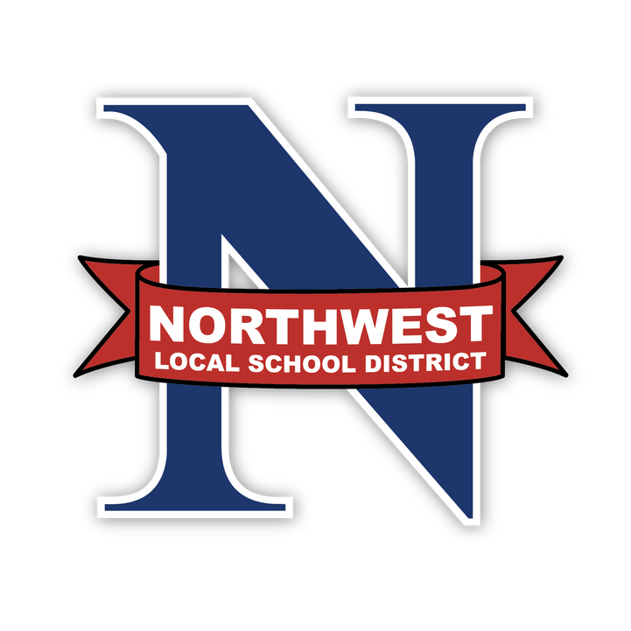
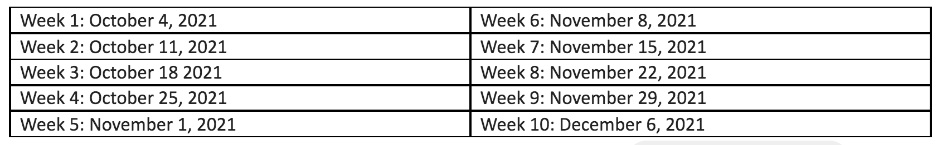
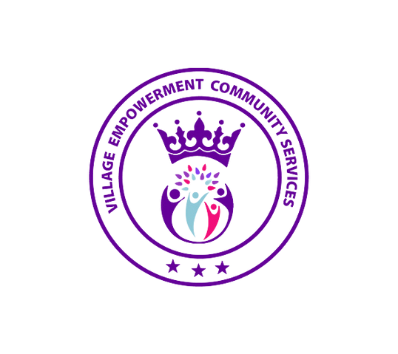
To register online, visit: bit.ly/NWLSDParentProject,
 |  | LOCAL SCHOOL DISTRICT  ING  UTIONS  arents. Transforming Families. | REGISTER NOW!  NO COST TUITION: Childcare (all ages) and  dinner is provided!!  TO SIGN UP ONLINE:
NORTHWEST

LOV
SOL

Empowering P

• Participate • Learn how • Answers fo • Improve sc • Find resour

This 10 wee 5-10 years
virtually or in-person
to never argue with your child again!
r parents with children diagnosed with ADD/ADHD! hool performance!
ces to help your family!

k series is designed for parents with children ages old within the Northwest Local School District
or contact Lindsey Gibson at (513) 648-4085 or Lisa Murray (513) 806-6686

Groups will be held on Mondays for 10 weeks (dates below) from 5:00-8:30 PM*.

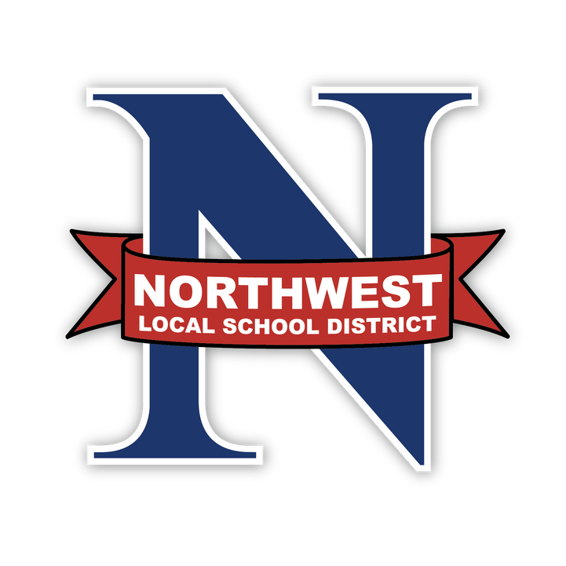
*Group sessions will be held at Houston Conference Center (3310 Compton Rd., Cincinnati, OH 45251).
This is a collaborative effort of Northwest Local School District an The Village Empowerment Community Services.

