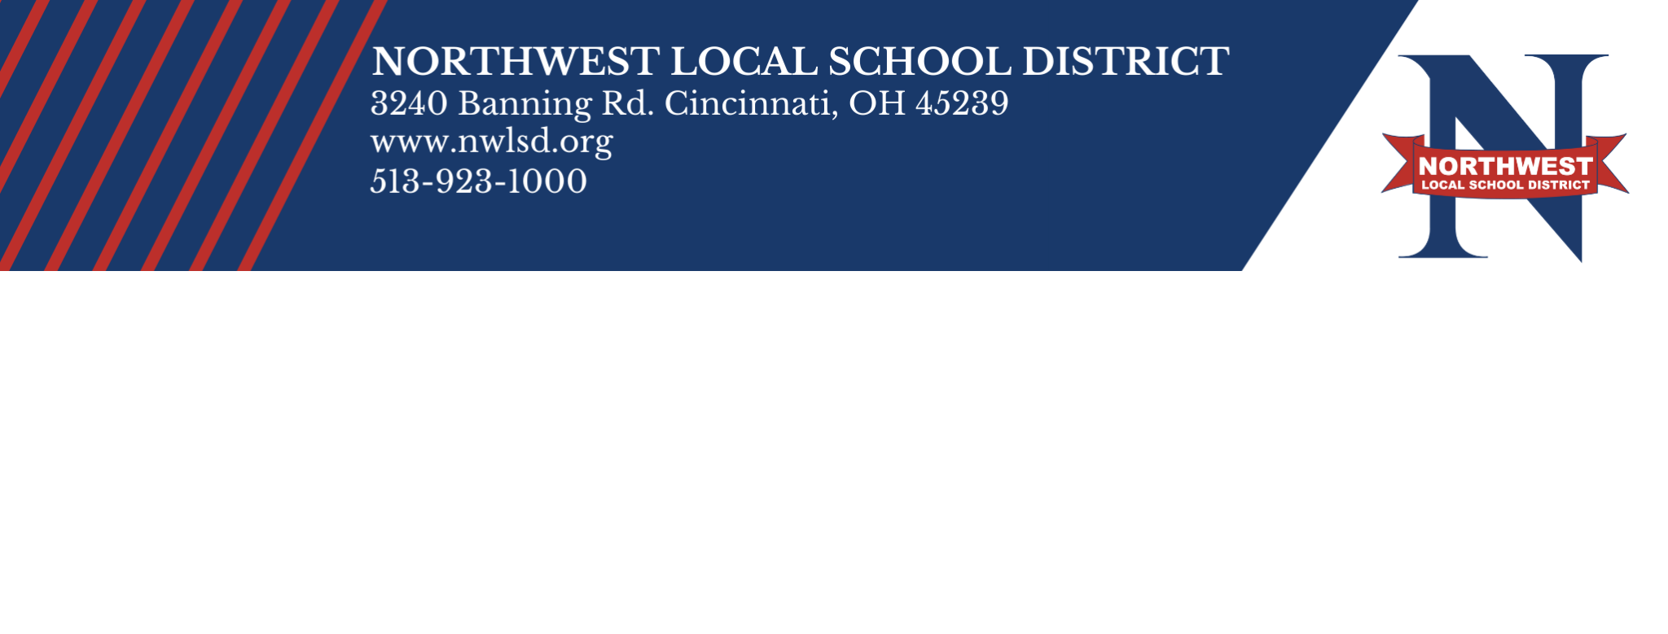

Northwest Local School District Board Hires New Superintendent CINCINNATI, OH - On July 19, 2021, the Northwest Local School District (NWLSD) Board of Education voted unanimously to hire the district’s new superintendent after conducting interviews. Darrell Yater, who was one of three candidates interviewed for the position that was posted by the Hamilton County Educational Service Center, was selected as the candidate of choice. Yater’s contract as the new Superintendent of NWLSD will begin on August 1, 2021.

“We believe that Darrell will be an excellent Superintendent for Northwest Local Schools,” said Mark Gilbert, NWLSD Board President. “He brings an immeasurable set of skills to the district. He is approachable, collaborative, goal driven, and growth oriented and his vision for the future of the district is impressive,” said Gilbert. Darrell’s contributions to NWLSD as an educator are not only recognized within the district, but nationally. In 2007, he was honored as the Milken Educator of the Year, an award only given to top educators around the country.

Darrell has been an employee of NWLSD for over 20 years. He has served in various capacities throughout the district, granting him a unique awareness and perspective of the district’s needs. He began his journey with Northwest as a Language Arts Teacher, and his career has led him down a path to also serve as a Curriculum Specialist, Building Administrator, and Assistant Director of Special Education. In 2018, Darrell was hired as the Assistant Superintendent, a role that he has been serving in ever since.

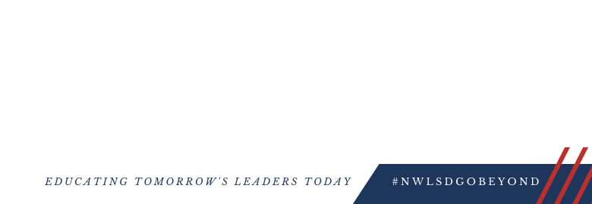
“I am thankful Yater. “I look f begins our tra community to forward with o

Township, Green Township and Springfield Township in Hamilton County, Ohio. The district educates approximately 9,400 students within one pre-school, five elementary schools, three middle schools and two high schools.

NWLSD Mission
The Northwest Local School District will create a responsive learning community where all students are valued, challenged and guided along a pathway to success.

NWLSD Core Beliefs:

● We believe students and staff excel best when they feel welcomed in the building, safe in their classrooms and trustful of each other
● We believe all students and staff can learn and deserve opportunities to show and achieve success ● We believe valuing diversity and working to understand one another is vital and important
● We believe a high priority should be placed on providing holistic support to ensure success for all
● We believe building and maintaining collaborative relationships with community member is foundational to teaching and learning in NWLSD

